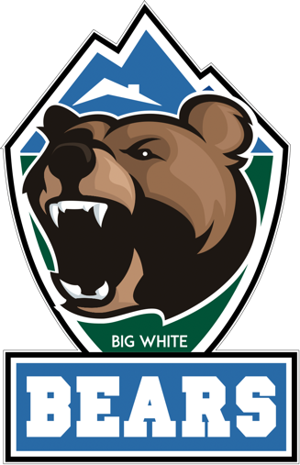
BIG WHITE COMMUNITY SCHOOL
BEAR WEAR ORDER FORM
Every Student gets one FREE T-shirt: please select the size and colour.
If you wish to have additional t-shirts or hoodies for your child or your family please note the quantity, color and size.
Item | Color | Price | Quantity
T-Shirts - Youth (S-XL) | Navy or Grey | $18 | Navy _____________ Grey ____________  Size____________ Size_____________
T-Shirts - Adult (S-XL) | Navy or Grey | $20 | Navy _____________ Grey ____________  Size____________ Size_____________
Hoodies/Pull-over - Youth (SM-XXXL) | Navy or Grey | $26 | Navy _____________ Grey ____________  Size____________ Size_____________
Hoodies/Pull-over - Adult (SM-XXXL) | Navy or Grey | $30 | Navy _____________ Grey ____________  Size____________ Size_____________
Payments: Cash or cheque to Patrick O or you can submit an e-transfers to bwcspac@hotmail.com

