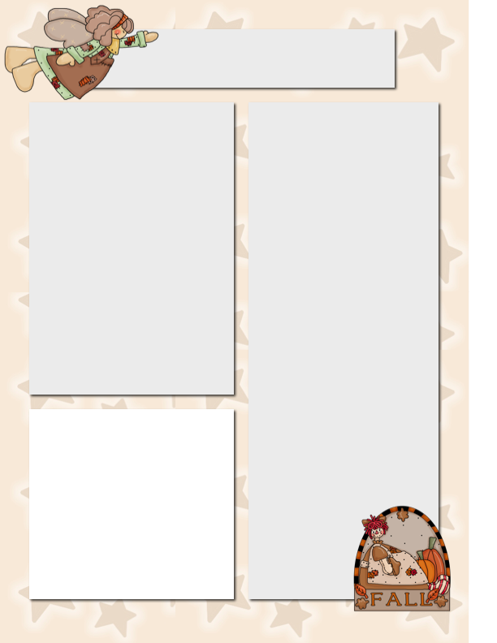

**Dates to Remember**

Sept 21 Strong Start Begins

Sept 22 Intermediate Virtual Book talk

Sept 24 Terry Fox Run

Primary Virtual Book Talk

Sept 30 Orange Shirt Day

Oct 1 Kindergarten Hearing screener administered by IH

Oct 5-8 Fire Prevention Week

Oct 12 Thanksgiving (No School).

**A reminder for parents who have not yet returned permission forms and student fees please do so.**

**Ms. Montani/Mr.O’s Class**

* Welcome back! My name is Carolina Montani (The kids call me Miss M) and as you may know, this year I will be partnering with Mr. O to teach your child in grades K-3.
* I am very excited about this opportunity, and even though these are challenging times for students, parents and teachers, I know we will all make the best out of it.
* Although we have only been in school for a few days, I can tell this will be a very fun and energetic group of kids! Everyone is getting along and playing well together. In the classroom we are getting to know each other better and learning the classroom and school expectations.
* In the mornings we are doing a check-in, where we learn different emotions and are beginning to describe how, and we feel and explain why.
* We have started our calendar, ask your child about the days of the week song or the birthday song to see if they remember it! We have started our word work program, my goal for the students is for word work to become an independent activity where they practice sounds, writing and are able to share that learning with others.
* During math we are starting with number concepts and playing math games to get our brains thinking in a mathematical way! I am very excited for the students to show me what they know and most importantly, learn who they are as people.
* Please do not hesitate to email me at  [carolina.montani@sd51.bc.ca](mailto:carolina.montani@sd51.bc.ca)

if you have any questions

or concerns.

We will be participating on zoom to celebrate Sea Otter Awareness Week and learn all about sea otters at this kid-friendly virtual book talk. Author Karen Autio (Kelowna resident) will share what she learned about sea otters while researching her latest book, Kah-Lan and the Stink-Ink. And Illustrator Emma Pedersen will give a lesson on how to draw a sea otter. I am very excited to give both classes opportunities for guest presenters.

Big White School Bears News

September 18th, 2020

**Virtual Book Talks**

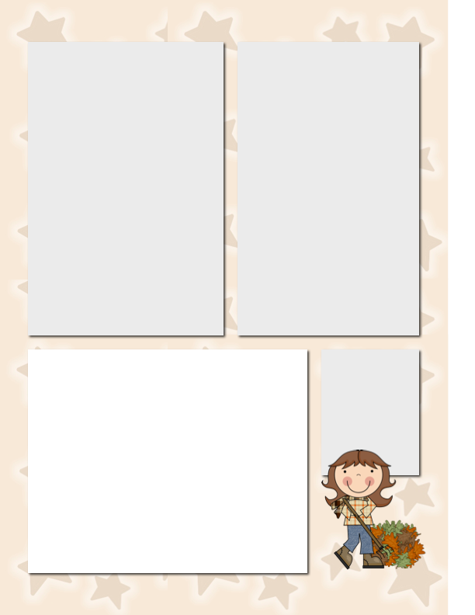

**PAC Meeting**

**Wed. Sept.23rd**

**Location TBA**

**Time 6:00pm**

Mr. Hayes Class

Welcome back to another school year! I am looking forward to this school year. We have hit the ground running this year and already have a lot on the go.

One of the main topics that we will be focusing on this term is having the students reflect who they are as learners. Through journaling, art and class discussions we are going to try to figure out what type of learner we are as well as what we need to be successful.

At the school we have guiding principles of making “TRACKS.” It stands for

Teamwork Responsibility Attitude Courage Kindness Self-Regulation. The students have been exploring how they can use these ideas to help guide their choices. Be on the lookout in the next few weeks for their completed project where the students are designing what “TRACKS” means to them.

In math the grade 4 and 5 students are exploring various addition and subtraction strategies and the grades 7,8, and 9 are exploring Algebra. Did you know that the Romans didn’t have any issues with Algebra because X was always equal to 10?

**Terry Fox Run**

We have a strong tradition about celebrating the Terry Fox run at Big White School. We are approaching 20 years of running and raising money for the Fox foundation. If you would like to make a donation through the school, please use the only platform only this year. <http://www.terryfox.ca/BigWhiteCommunitySchool>

Furthermore, I have been informed that no parents are to participate while the kids are running this year due to school restrictions. I apologize in advance for this.

The Terry Fox run will take place Thursday September 24th 1:45pm.

**Want to Add a Picture Instead of Text?**

Click on the text box. Go to the insert menu above and insert a picture! ☺

**Homework to Expect**

**This Week**

Monday: blah, blah, blah, blah, blah, blah, blah, blah, blah, blah

Tuesday: blah, blah, blah, blah, blah, blah, blah, blah, blah, blah

Wednesday: blah, blah, blah, blah, blah, blah, blah, blah, blah, blah

Thursday: blah, blah, blah, blah, blah, blah, blah, blah, blah, blah