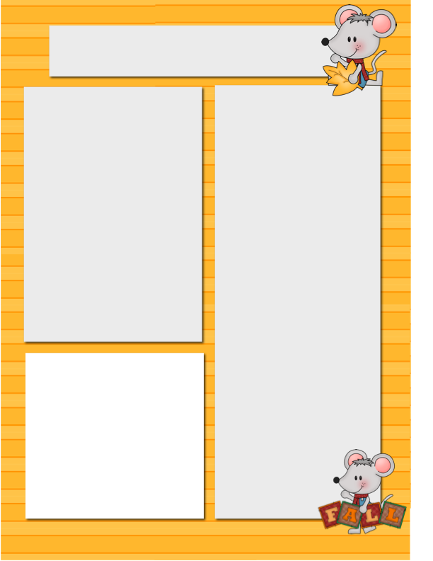

**Mr.O’s Bear Den**

Over the last 2 weeks, kids have been engaged with the outdoors.

From building forts together as a school to making journey sticks this past week in the primary class.

The journey stick told the story of a student’s journey through the woods.

The top, middle, and bottom of their stick should represent their journey from beginning to end. Their story and stick were sent home for the weekend.

In music, our ukuleles have arrived, and the older students and I will be tuning them up this week and learning a couple of cords to start getting a few songs under our belt.

In the primary class, we are focused on creating music rhythms, playing games, singing, and dancing. In art, we are focusing on online art and will be working on self-portraits this coming week.

If you have any questions about what’s going on at school, please email me anytime or call the school and please check online on our big white school website for everything BEARS!

Wishing everyone  
a safe and happy upcoming Thanksgiving Holiday!

Big White School Bears

Newsletter

***October.2/2020***

Our first field trip of the year and in a while will be Friday, October 16th our students will be traveling to the Air House in Rutland and then off to MacMillan Pumpkin Farm in the afternoon. The bus will leave at 8 am from BWCS and arrive back at BWCS at 4 pm.

**Dates to**

**Remember**

Oct 5-8. Fire Prevention Week

Oct 12 Thanksgiving (No School)

Oct 14 PAC Meeting @ 2pm

Oct 15 Indigenous Presenter

Oct 16 School in Session

Field trip to Kelowna

Oct 19 Virtual Bard on the Beach

for Intermediates

**Please Note…**

Winter is coming please make sure that children have all their warm

gear as October rolls in and the cooler weather hits the mountain.

**Kelowna Field Trip**

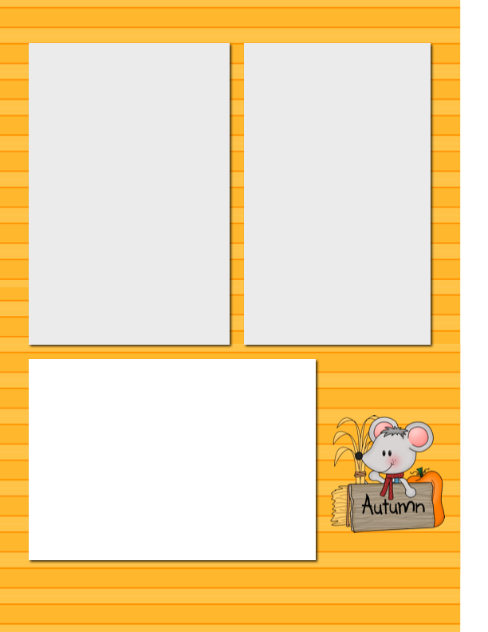

**Primary Photo**

Parents we are in search of a photo of your child or family that takes place on a specific landform (like a ski vacation, ocean, at the lake, etc.)

Please bring for Monday October 5th

**Mr. Hayes Intermediate Class**

The intermediate class is started to get into the swing of things.  We have been working hard setting up our blogs and are starting to send out the links and passwords to our parents.  If you do not see a link/password for your child’s personal blog by Wednesday October 7th please let Mr. Hayes know.

As a class we are creating a character to base a story about.  We have discussed how everyone’s needs as a writer are different which has led us to change our view about what writing looks like.  We have some students who are building, some drawing, and some writing to spark their creativity and help develop their ideas.  There has been an emphasis on the students developing a sense of what they need as a learner to succeed.

In Math the grades 4’s and 5’s are continuing to explore addition and subtraction techniques.  They have been working on how to add to the nearest 10 and then add the remainder.  The Grade 7’s, 8’s, and 9’s are continuing to explore Algebra.  The big focus this week has been on how to factorise an equation.

In art we are continuing to explore the use of lines. The students have started developing reflections of their artwork on their blogs.  We are emphasizing a focus on the process of our artwork rather than just focusing on the end product.

**Homework to Expect**

**This Week**

Monday: blah, blah, blah, blah, blah, blah, blah, blah, blah, blah

Tuesday: blah, blah, blah, blah, blah, blah, blah, blah, blah, blah

Wednesday: blah, blah, blah, blah, blah, blah, blah, blah, blah, blah

Thursday: blah, blah, blah, blah, blah, blah, blah, blah, blah, blah

**Want to Add a Picture Instead of Text?**

Click on a text box. Go to the insert menu above and insert a picture! ☺



**Fire Prevention Week**

We are looking at running our annual fire prevention week along with our WEP October 5th-October 8th. Students in both classes will be educated in fire safety each afternoon. This event usually sees us interacting in close proximity with WEP this year will look very different with everything being outside and distanced from each other. The WEP has assured the school this will be a great event as in years past!

**Ms. Montani’s Primary Class**

We have been in school for two weeks and the kids are quickly learning and following classroom and school expectations, In the morning we do a check-in with ourselves and the teacher, so we understand and express how we are feeling. We are also doing calendar, which involves figuring out what day it is, month, season, the weather, important dates and looking at patterns; ask your child about the days of the week song or the birthday song to see if they remember it! I have sent home a copy of your child’s words that they are learning at school during word work, I really appreciate that parents are taking the initiative to help their kids with some of the challenging words. For now, I will only send a new list every second Monday, once we are more into our routine, I will send a new list every Monday and have a test every Thursday.

I have also sent home handwriting practice with some students; it does not need to be completed right away nor brought back to school however it is a way to support your child’s writing at home and something we are practicing at school as well. This week we have taken advantage of the beautiful weather and been spending more time learning outside. We Have gone on a leaf hunt, created patterns with our leaves, sort them and counted them. We also talked about what trees need to survive and how they eat and breathe through leaves. In science we are beginning our landforms unit, we are connecting what we already to know to our surroundings. For next week, please bring a photo of your child (or family) at a landform (mountain, lake, cave, ocean, visiting hoodoos in Alberta, prairies, etc.) for your child to share with the class. Please do not hesitate to email me at  [Carolina.montani@sd51.bc.ca](mailto:Carolina.montani@sd51.bc.ca) if you have any questions or concerns.