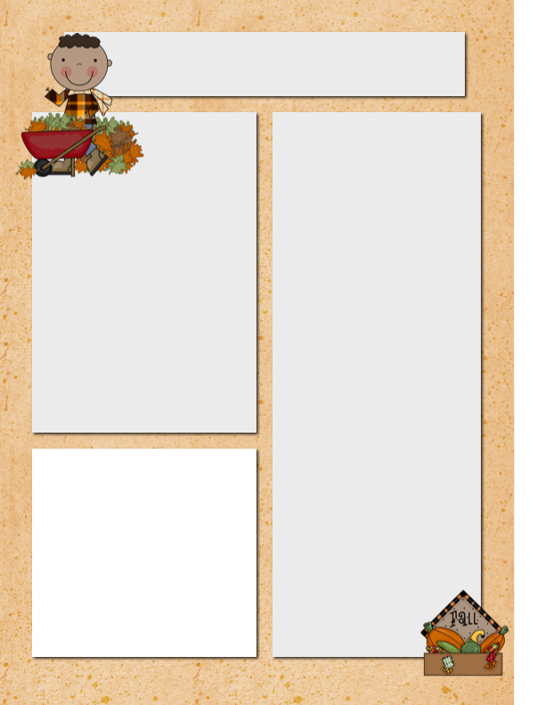

**The Bears Den w/Mr.O**

* **In the Intermediate class kids have been working on intro to French on duo lingo. Hope to start up our unit on family.**
* **In Intermediate music we are working on fingers, position and grip of our ukulele. We have learned C and F cords and working to learn how to go between both and some are working towards learning the G7 cord. We are starting to practice “you are my sunshine”. Very excited long process and the kids know that some are frustrated but it is all about practice.**
* **In primary music we have learned 2 new songs “magic penny” and “you are my sunshine” Kids continue to enjoy go noodle signing and dancing. This coming week in art we are focusing on lines, shapes and Halloween projects.**
* **Hot lunch will be starting up in November and very excited to get this going with foods the kids will eat and enjoy.**
* **Later in November we will be attempting zoom parent teacher conferences as parents are not allowed within the school. Looking at alternatives with our principal.**
* **Wishing everyone a short and restful weekend.**

Big White School Bears

Newsletter

October.17, 2020

***November 9th, 2017***

**Field Trip**

Our field trip to Kelowna was excellent! The Air house was great the kids and the adults had a blast jumping all over the gym. After a short detour for some ice cream we shuffled over to McMillian Pumpkin farm and enjoyed a great hayride followed by the corn and hay mazes! Hopefully, everyone got a pumpkin to take home! I love taking the school on trips and this was a great day as the weather cooperated nicely for us! Thank you to everyone that had a hand in our field trips success!

**Dates to**

**Remember**

Oct 19 Bard on the Beach Virtual Workshop Intermediates

Oct 21 Take Me Outside Day @ Mission Creek Park

Oct 29 BWCS Halloween Extravaganza

Nov 10 Zoom Remembrance

Day Ceremony

Nov 11 Remembrance Day

(No School)

Nov 12 Avalanche Canada Presentations @ BWCS

Nov 13 School in session

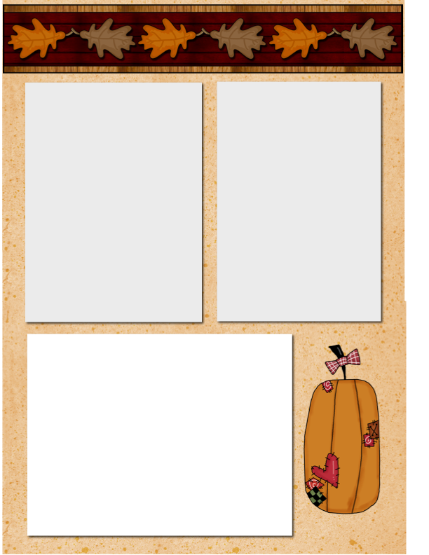

**Ms. Montani**

Happy Thanksgiving! Hope everyone had a lovely time with friends and/or family. This week we have been practicing our new word work words, from now on, tests will be every second Monday, so the next test will be on Oct 26th, this way the students have one more weekend to study the words and when they come to school they are rested and have energy for it ☺

We also had Ginette from our Aboriginal Education department come out to visit our school on Thursday, Ginette taught us how to make talking sticks and discovered more about Indigenous ways of learning. The kids had an opportunity to do some aboriginal drumming with the intermediate class buddies. What a great week!

**Mr. Sabourin’s Gr. 4-9 Class**

We have a lot on the go in the intermediate class. The students are continuing to develop their characters for the story that they are creating. We have been exploring how we can add depth to our characters. We are working on creating characters who have different qualities to help the reader connect with them.

The student's blogs are now up and running. I have seen some parents beginning to comment on what the students are posting. Please take some time to explore their blogs and start a conversation about their work. If you are having any issues accessing your child's blog, please let me know. The students have been working hard at how to give feedback to others while being positive, specific, and helpful.

In Art we are finishing up a new assignment while using lines. We are also beginning to explore who we are. The students are creating a digital collage about their interests. Once all the collages are done, we will be posting them and having the students guess who created which collage.

We have been working on some STEM challenges in science. This week while working with a younger buddy, the students were given one sheet of construction paper, a pair of scissors, and a glue stick to see which group would build the largest paper chain. With a lot of teamwork and different strategies the groups were able to create surprisingly long chains. The longest ended up being roughly 12 feet.

**Want to Add a Picture Instead of Text?**

Click on a text box. Go to the insert menu above and insert a picture! ☺

**Homework to Expect**

**This Week**

Monday: blah, blah, blah, blah, blah, blah, blah, blah, blah, blah

Tuesday: blah, blah, blah, blah, blah, blah, blah, blah, blah, blah

Wednesday: blah, blah, blah, blah, blah, blah, blah, blah, blah, blah

Thursday: blah, blah, blah, blah, blah, blah, blah, blah, blah, blah