**HEALTH PROMOTING SCHOOLS**

**NEWSLETTER**

**Content for Parent Newsletters**



February 2023

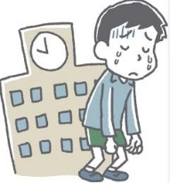**MENTAL HEALTH**

**Challenges with School Attendance and Refusal**

[School Anxiety & Attendance Challenges for parents and Caregivers: Webinar Series](https://keltymentalhealth.ca/school-attendance-webinars)

|  |  |  |
| --- | --- | --- |
| |  | | --- | |  | |  |
| https://cdn.cyberimpact.com/clients/35921/public/bb54cad9-6718-4c93-99c2-aa1014bd7b55/image/logo-ask-auntie_2x.png?1674501559625 | |  | | --- | | **Ask Auntie**  Ask Auntie is an online and community-based wellness program, for Indigenous girls aged 10 -14 living in BC. Rooted in the Cuystwi program, the Ask Auntie program takes girls on a journey to learn about health and their bodies, connection and relationships, culture and the history of colonization, and what it means to be strong Indigenous girls.  For more information see: [Ask Auntie — Indigenous Youth Wellness](https://www.indigenousyouthwellness.ca/wellness-quests/ask-auntie) | |
| |  | | --- | |  | | |  | | --- | |  | |

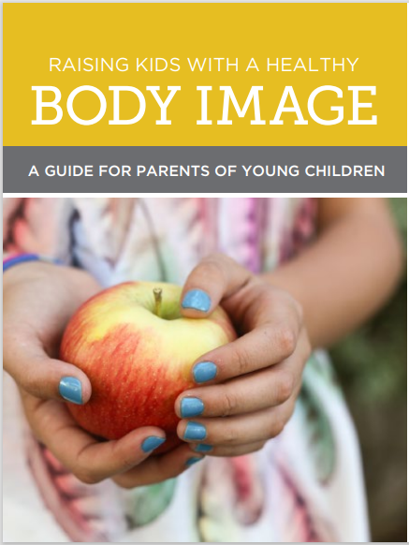**NUTRITION**

February is Eating Disorder awareness month. Have a look at the following resource on ways to support healthy body image at home. [Raising Kids with a Healthy Body Image](https://jessieslegacy.com/wp-content/uploads/2018/05/Raising-kids-with-a-healthy-body-image-WEB-FINAL.pdf)

**RADON**

**Interior Health Pilot Project Testing for Radon in Schools**

Radon is a radioactive gas that is formed naturally in the ground. It has no colour, odour, or taste and can accumulate indoors, particularly in basements and ground floors. Radon is the second leading cause of lung cancer in Canada after smoking. Spending long periods of time in rooms where radon is present can increase the chance of developing lung cancer. The only way to know radon levels is to test for it.

Interior Health is currently collaborating with schools on a radon testing pilot project. The project includes reviewing radon results and supplementing ongoing testing efforts. Interior Health will work with school management to reduce radon levels where high levels are found.

According to the BC Centre for Disease Control, radon levels are generally higher in the Interior region than other areas of the province. While this project focuses on schools, this setting only accounts for part of the total exposure people may receive. Radon may be present in other buildings in your community, including homes. We encourage everyone to test their home for radon.

For more information and resources about radon in BC and to order a long-term test kit visit:

* [Interior Health’s Radon Information Page](https://www.interiorhealth.ca/health-and-wellness/environmental-health-and-hazards/radon-gas) - Radon Overview and Resources
* [BC Centre for Disease Control](http://www.bccdc.ca/health-info/prevention-public-health/radon) - Radon Overview and BC Mapping Information
* [BC Lung Foundation](https://bclung.ca/radon) - Long-Term Test Kit Information and Radon Projects in BC

If you have questions, please contact the Healthy Schools team at [HealthySchools@interiorhealth.ca](mailto:HealthySchools@interiorhealth.ca).

