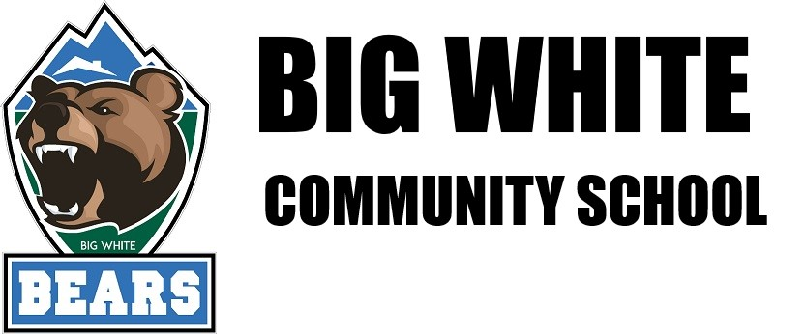

WELCOME TO THE BEARS DEN CAFÉ
HOT LUNCH PROGRAM

November and December 2020

$5 per lunch per student
please bring cash for all hot lunches please to help pay back hot lunch providers on time.

Menu

November 4th – Hot Dogs or Veggie Dogs, Veg Sticks, Chocolate Milk
Circle one or both: Hot dogs or Veggie Dogs

Nov.25th - Cheese or pepperoni pizza, Caesar salad, Veg sticks, Juice
Circle one or both: Hot dogs or Veggie Dogs

December 2nd - Pasta, Salad, and Garlic bread
Circle one or both: Red Sauce or plain butter

December 16th - Chicken nuggets, veggie sticks, cheese strings

