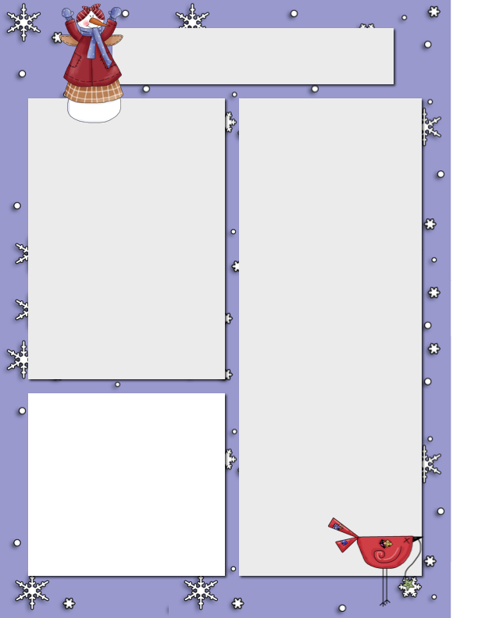

On Thursday we said farewell to Carter Mallis and his family. We baked vanilla cupcakes and he took home some goodies to share on their long trip ahead. We wish the Mallis family the best of luck in the future. We hope that this family will return back to the BWCS community in the future!

**Ms. M Primary Class**

We’ve started the month of February, and it will go by very quick! We’ve been very busy practicing our words, working on our math, using Mathletics, learning about ourselves and what we like, as well as learning about various emotions.

In math, for your grade 2 or 3 child, have them practice addition and subtraction with re-grouping. The kids are learning this concept in math and practicing at home will help build that mathematician confidence. Kindergarteners are doing really well with subtraction and addition up to ten, to help them at home, have them practice writing their numbers. Grade 1s are showing understanding of ordinal numbers (1st, 2nd, 3rd…etc), you can help them practicing at home by lining up toys and asking them to tell you which toy is first, second, etc.

The kids did really well with their word work. K’s are learning about the letter M and their test will be tomorrow (Thursday), and next week will be doing letter N. The other kids are either on list 8 or 24, please try to practice at home as it will help with their sorting, reading and writing fluency at school. If you have any questions or concerns, please don’t hesitate to email me at Carolina.montani@sd51.bc.ca

**Dates to Remember**

Feb 8 Snowshoeing

Feb 10 Hot Lunch

Feb 11 Valentine’s Day

Ski Day

Feb 15 Family Day (No School) Feb 16 Ski Day - Tuesday

Feb 19 School in session - Friday

Feb 22 Snowshoeing

Feb 23 Kindergarten Hearing Screener

Feb 24 Pink Day

Feb 25 Ski Day

**Please Note…**

Pac Meeting March 3rd, 2021 Wednesday. 2pm via zoom.

Big White Community School

***Feb. 6, 2021***

**Farewell Family**

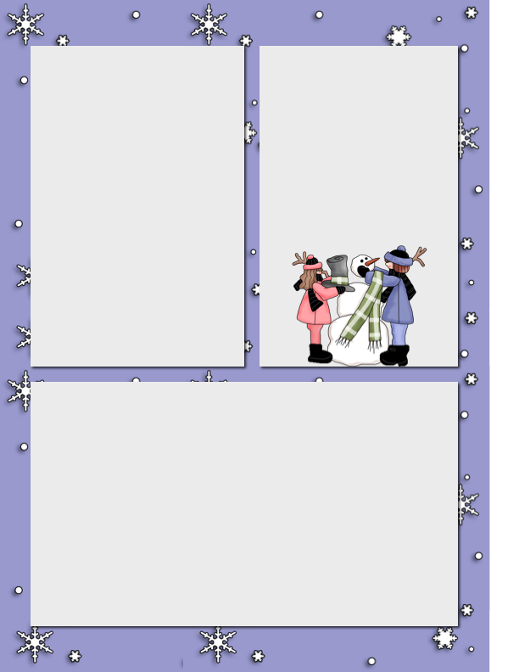

**Mr. Hayes Class**

That’s not to say that we have not been doing a lot in class, we have been doing plenty of Mathletics for our math. We have also been doing coordinates and Mr. Hayes made that quite fun for us. He gave us a list of coordinates that, when connected made up a drawing. The first one was a wolf. The second one was 2 scuba divers. The third one was of a robot. We could also make our own but not all of us did.

 We’ve been doing some Ozobots for our technology. We did the Spheros at first, but they wouldn’t charge so Mr. Hayes ordered the Ozobots as a replacement. The Ozobots follow color patterns that you put in using Black, Red, Blue, and Green markers. For instance: blue, green, and red give the Ozobot a “nitro boost” which makes it go super-fast!

 For art, we put together a presentation about a style of art and we did a piece of art in that style. Then we presented to the class. Some of us did a Kahoot about our style of art. A Kahoot is a fun quiz that you can design.

 For science, we’ve been researching cells. We had to put together a presentation about eukaryotic and prokaryotic cells, the differences between them, the similarities etc.… we also had to make a eukaryotic cell model and a prokaryotic cell model. You can see the models on the edublogs website (<https://intbwcs.edublogs.org/2021/01/27/voice-and-choice/>) . We were put into groups of 3 for this project. We also did a crossword about animal cells and plant cells and used virtual reality to view them on the Ipads.

Valentine’s Day

Thursday February 11, 2021 will be our Valentine’s Day at BWCS this year as real valentine’s Day falls during Family Day long weekend. If you have cards or other children, I believe that class lists were sent out and if you need one please contact Mr.O.

Ski Day will happen also on that Thursday!

**Mr. Hayes Class**

In the Intermediate class, we have been spending a lot of time outside along with the Junior class. Every week we have been skiing on Thursdays and spending the majority of the afternoon outside every Wednesday. Every other week, we have been snowshoeing on Monday’s and skiing on Tuesdays. The 1st week we went snowshoeing and the 2nd week we went skiing and the additional activities continue to alternate throughout the weeks.