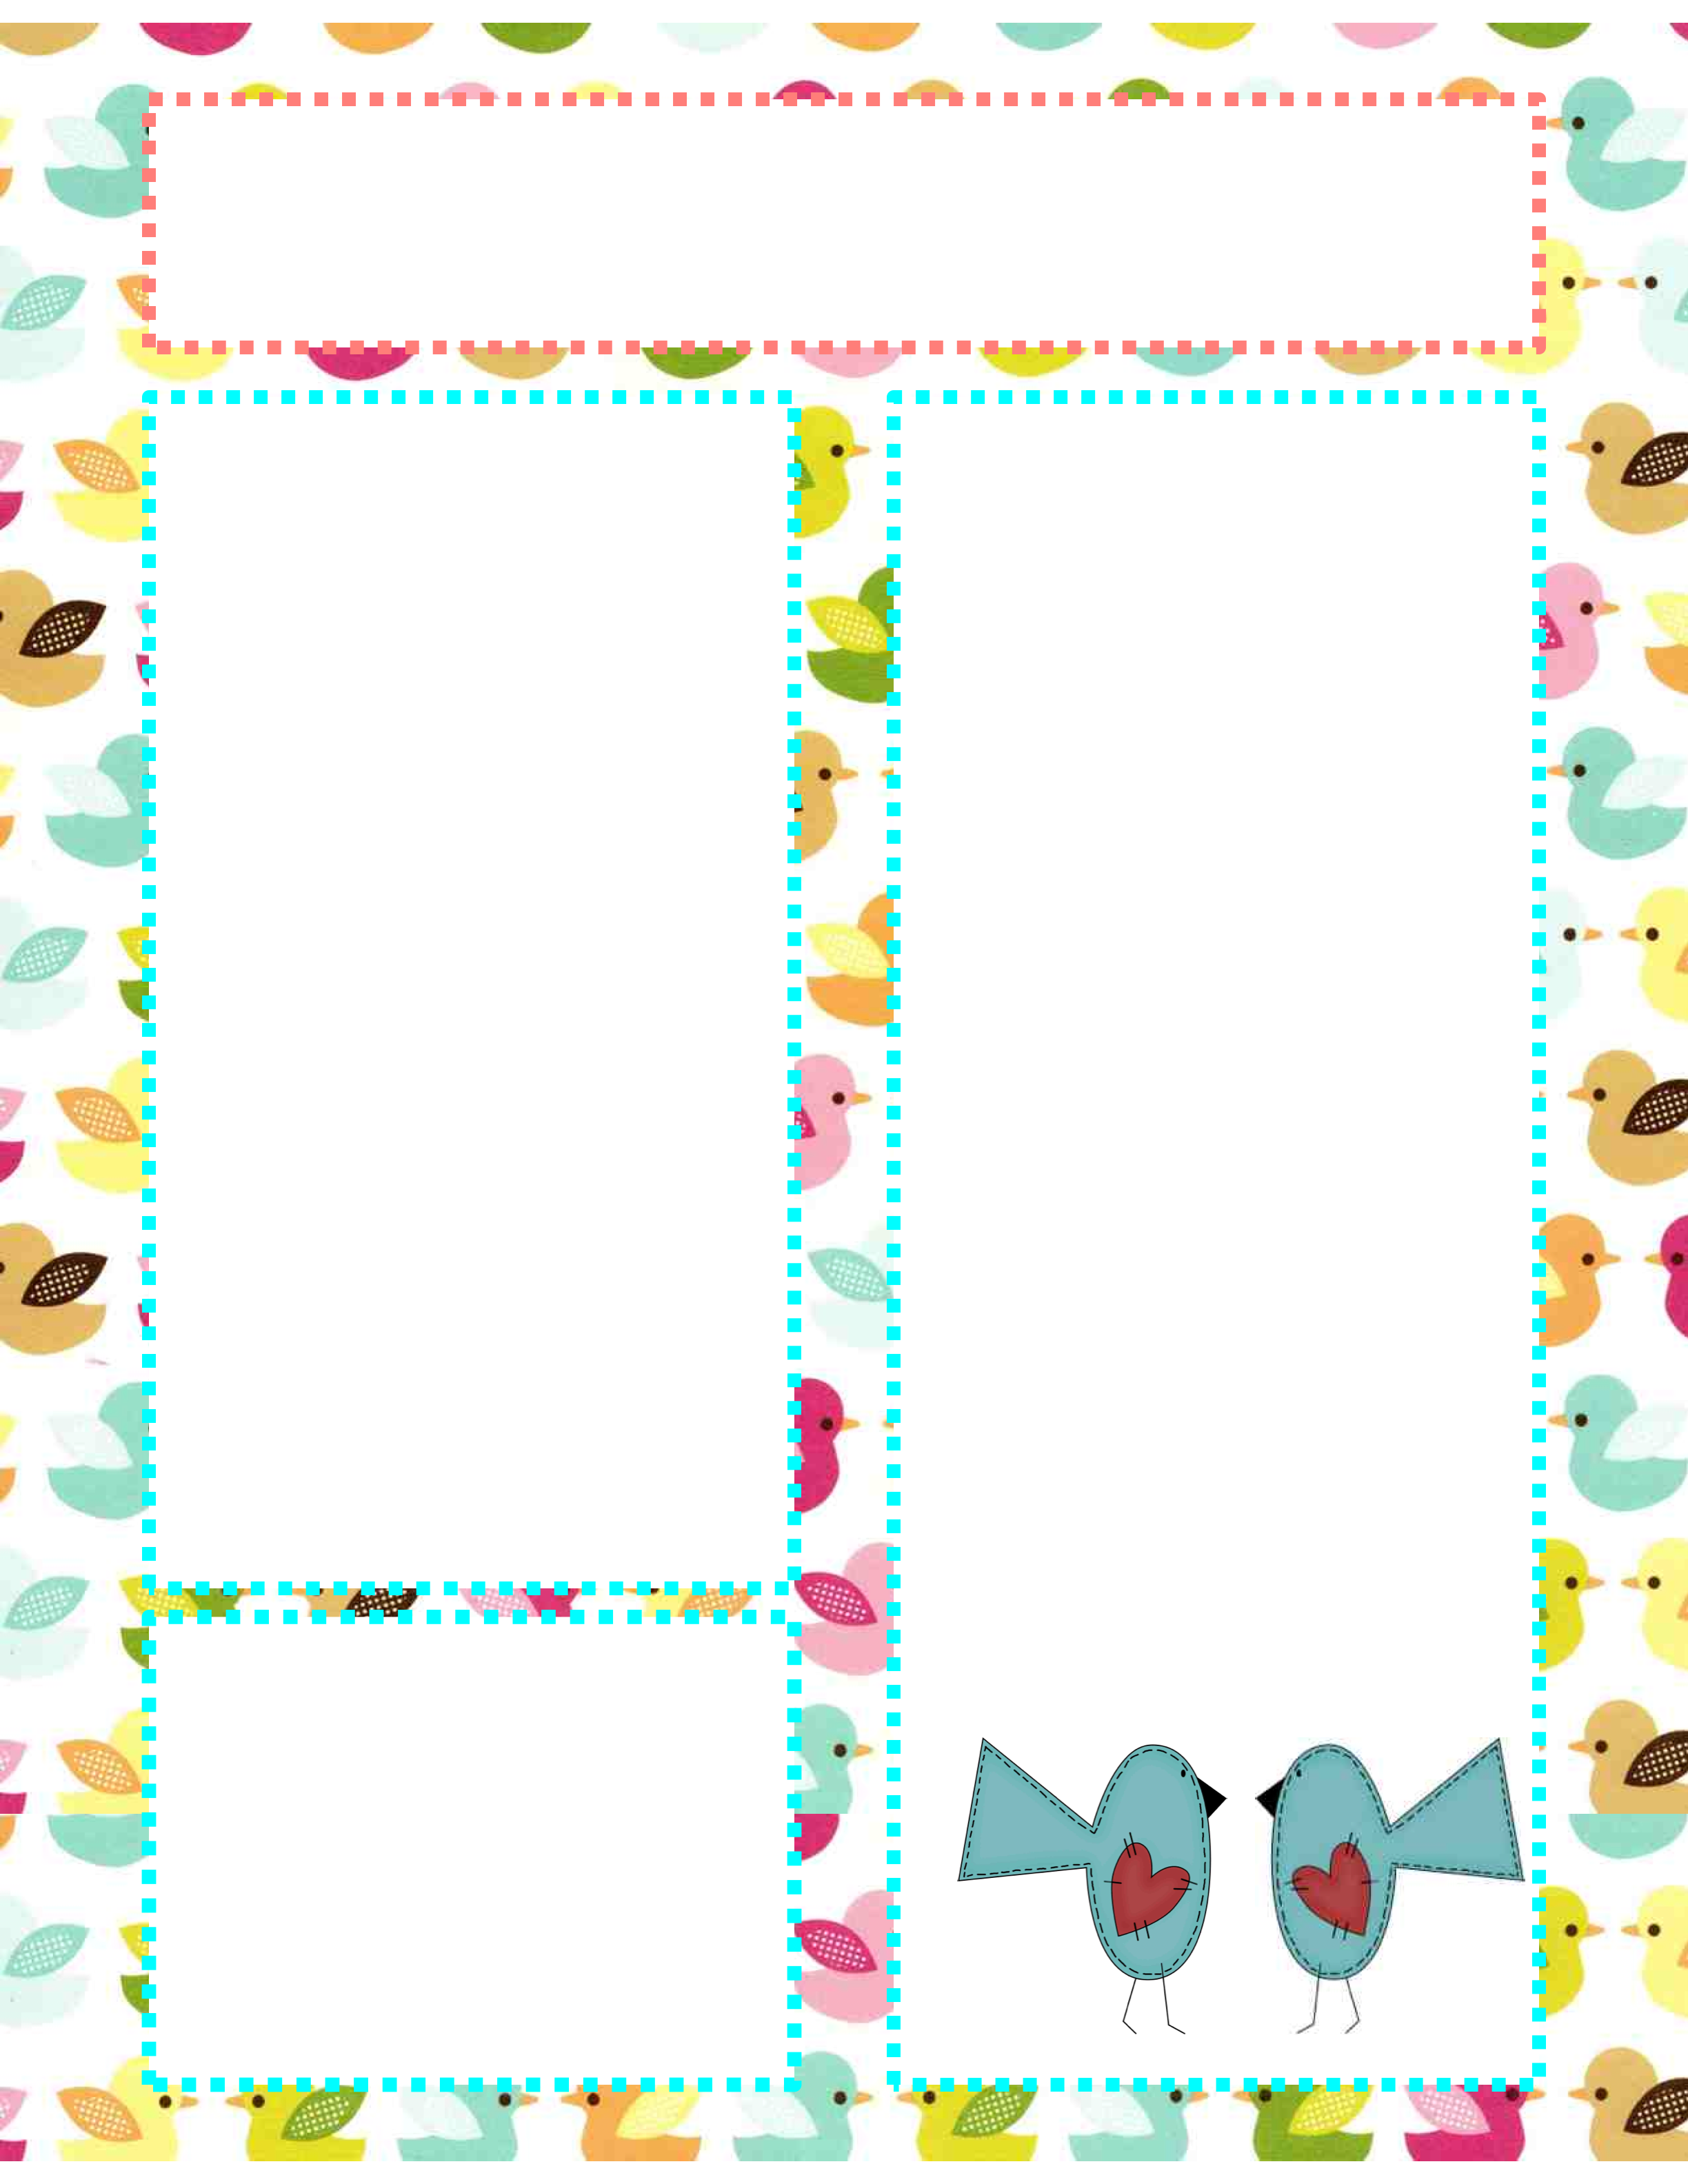

**PAC**

**Our next PAC Meeting will be Wednesday May.5, 2021 @ 2:00pm via zoom.**

**Dates**

**to Remember**

Apr. 21 Early dismissal Day pick up @ 2:30pm

Bear Spirit Day

Apr. 22 International Book Day

Apr. 27 Hike Day

Apri. 29 Field Trip (Kelowna Curling Club and Mission Creek Park)

May. 13 Field Trip (Knox Mountain)

May. 24 Victoria Day (No School)

May. 25 Hike Day

May. 28 School in Session

Field Trip (Okanagan Rail Trail/City Park)

Big White School

April.15th, 2021

**Ms. Montani**

I hope everyone had a fabulous Spring Break and feels rested and rejuvenated for the last 3 months of our school year! All the kids were happy to be back and play with their friends outside in the warm sun. It sounds like all the YES businesses were very successful, I am so proud of all kids, they’ve put so much time and work into their projects! This term we have been working on Mathseeds, we have a few more weeks left on our trial- if you want to check it out at home, download “reading eggs” on a tablet/ipad, or go to <https://readingeggs.com/>

The login for the students is their first name, capital letter of their last name and 333 – ex: carolinaM333

Password for everyone is 1234

I am hoping that we can get the program for next year as I noticed the kids really enjoy it and it is very interactive.

We have started to learn how to read maps, including a compass rose, map key and a scale. Play a north, south, east or west game with your child to test their knowledge!

If you have any questions or concerns, please don’t hesitate to email me at Carolina.montani@sd51.bc.ca

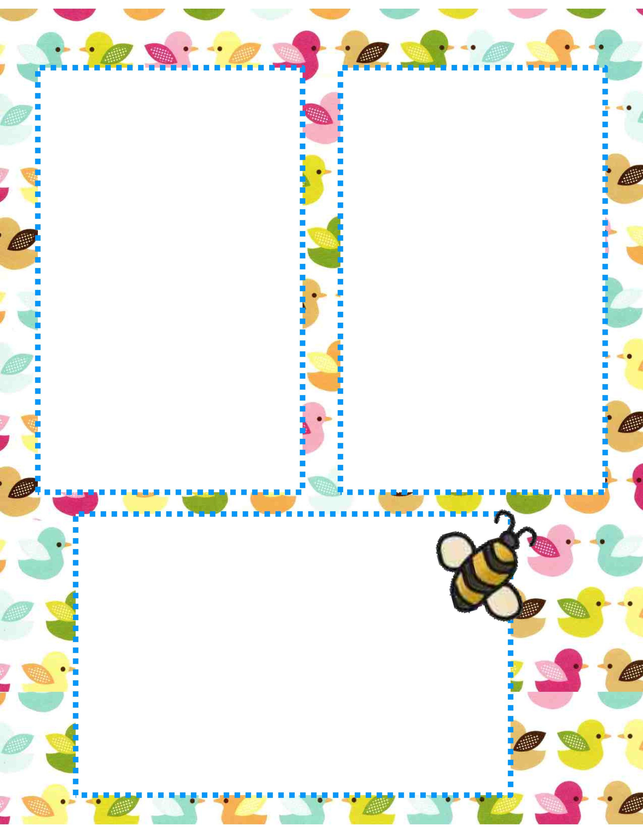

**Field Trips**

Field trips are in full swing! Trying to plan ideas and trips that don’t involve masks etc. I want to incorporate everyone. Our first trip will be to the Kelowna Curling club to do 2 things: Bocce Ball, Pickle Ball and then we will be transported to Mission Creek to play and Nature Walk! We will be sending lots of time outside at school and during field trips maybe sending a change of clothing each day if you don’t, would be a good idea with the snow melting quickly. Thanks parents.

**Mr. Hayes Class**

By Nicole Chisholm

In the Intermediate class, we have been having lots of fun and we have been working hard. We have been doing plenty of art, science, social studies, music, English, French and gym. Here is what the intermediate class has been doing for the last 2 weeks:

For science, we have been focusing on doing presentations on space. We made a poster, on a space topic, and we presented it to the class. For the poster we had to include 10 facts and 3 pictures. We are now working on a second poster or for this assignment, we can use PowerPoint, Word, iMovie, poster or another form of presentation. We are also working on different aspects of space.

For art, we have done a line project, we drew an image that reminded us of spring in the center of the page and we drew lines all around it to fill in the background. Overall, the artwork “popped off the page”. We drew an aurora borealis image with mountains in the background and have been doing a “mindful drawing” every morning. We have also been exploring positive and negative space.

For English, we have been working on our opinion essays of a topic of our choice. We have been exploring how to write an introductory paragraph, how to write a body and how to write a conclusion. We have not finished the essays yet but we will finish them soon. We will also have peers read our essays and give feedback after we are done typing them up.

For gym, we have been playing many different games. We have also done 2 snowshoe hikes. We have been playing hard at recess and we have been playing hard in gym.

For social studies, we have been learning about politics, our constitution, and our role as citizens. We have also been discussing what laws we would change if we could change laws. We have been exploring Canada’s democracy.

**Want to Add a Picture Instead of Text?**

Click on a text box. Go to the insert menu above and insert a picture! ☺

**Homework to Expect This Week**

Monday: blah, blah, blah, blah, blah, blah, blah, blah, blah, blah

Tuesday: blah, blah, blah, blah, blah, blah, blah, blah, blah, blah

Wednesday: blah, blah, blah, blah, blah, blah, blah, blah, blah, blah

Thursday: blah, blah, blah, blah, blah, blah, blah, blah, blah, blah