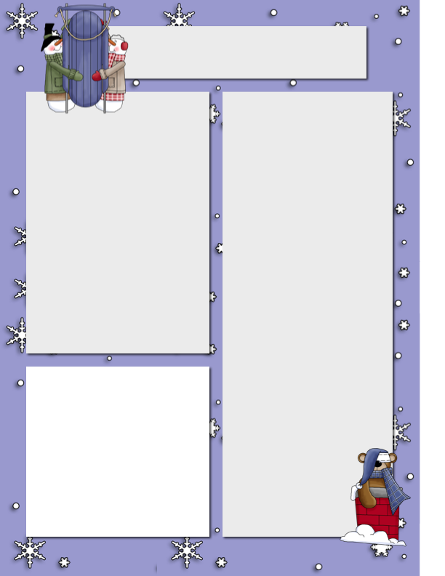

**Dates**

**to Remember**

Dec 14 Gingerbread house Building

Dec 15 Christmas dodgeball tournament

Dec 16 Hot Lunch

Christmas Concert 1:30 pm

Dec 17 PJ/Craft Day/Secret Santa

Last day before Winter Break

**Ms. Montani**

I want to start by letting everyone know that myself, and my family members are isolating at home for the next two weeks. While most of my family and I have tested negative for COVID, my partner is still recovering and has been feeling better already. Thank you for your calls or messages, I wanted to let everyone know that I am feeling well and have no symptoms. With that being said, I miss the kids already! I am hoping they will have a fantastic last two weeks at school before the holidays. Katie Wihak and Abby have been covering for Pat and I; we are so lucky to have them both, and knowing that the kids know them both and trust them, as well as knowing how much they care for your child, makes it easier for me to know that they are in good hands. They have been continuing with their calendar and word work. Tuesday was the last word work test of the year, and we’ll pick back up when we come back in January. They have been writing in their journals and have been reading stories together. For Math, the kids have been working on Mathletics or doing some Christmas Math with Katie. Just a reminder that on Thursday it is Green and Red day! Also, don’t forget to bring your Secret Santa gift to the school so we can place it under the tree. If you have any questions or concerns, do not hesitate to email me at [Carolina.montani@sd51.bc.ca](mailto:Carolina.montani@sd51.bc.ca)

I really hope everyone has a fantastic Christmas break, where we can all stay safe and have fun on the mountain!

Monday afternoon December 14 our classes will participate in a gingerbread building afternoon. Each student needs to have candies or whatever they need for decoration and a container of frosting please. The building pieces will be provided by the school. I hope to see some wonderful creations Monday afternoon.

Big White Community School

***Nov.24th, 2019***

**Gingerbread Building**

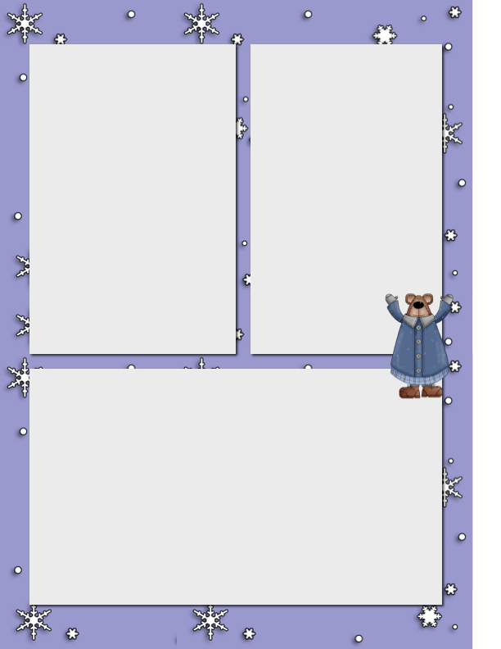

**Mr. Hayes**

**By Natasha Jones**

The past two weeks the intermediate class has been working on some more Mathletics and continued with their make writing stories. Some of the intermediates have been writing and some are brainstorming more ideas. The intermediates have been working on lots of art. They have done some more work with pastels and learning how to blend colors. A few of the intermediates participated in the ugly sweater day and the crazy hair day.  Some of the intermediates have finished their Christmas movie and some of the other groups are editing. They have also been working on the sets of the Christmas play and starting to film some of the scenes. The last week of school before Christmas break, they will be doing a few Christmas activities. They are having a red and green day, gingerbread house building Christmas dodgeball tournament, and a Christmas concert. The intermediates will also be opening secret Santa presents, doing lots of crafts, and watching a movie with the junior class on the last day!

**Ski Days**

Ski Days begin Thursday January. 7th. Fire department will pick up bags and equipment from BWCS and drop off at village. Students and staff will meet and leave from the mailbox area @ 1:00pm. Ski day dismissal happens from the hill. All groups that go out skiing will dismiss from the hill at 3:00 pm.

**PJ Day/Craft Day**

The last day of school is our annual PJ day and craft day before we go home for the holidays. Students rotate around a few different kinds of crafts put on my staff. Then after recess we do our Secret Santa opening all together as a school. In the afternoon a movie will play with popcorn and goodies for the kids to enjoy their last day.