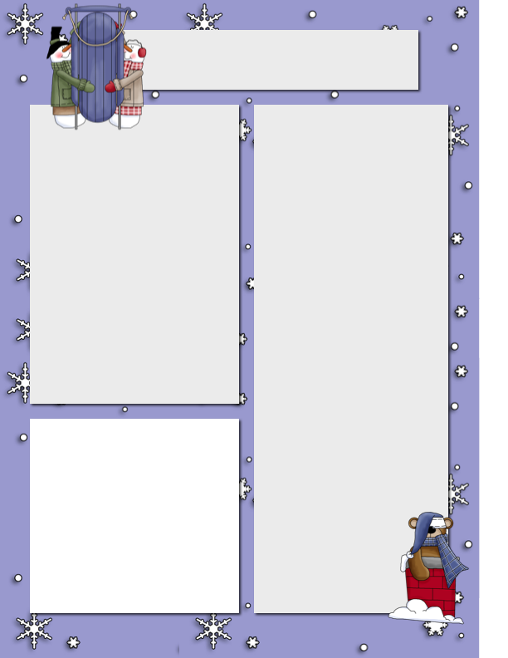

**Dates**

**to Remember**

Feb 22 Snowshoeing

Feb 23 Hearing Testing for K’s

Feb 24 Hot Lunch

Pink Day

Feb 25 Ski Day

Mar 2 Dr Suess Day

Ski Day

Mar 3 The Market Donated Hot Lunch

PAC Meeting

Mar 4 Ski Day

**Ms. Montani**

We are halfway through February; I hope everyone had a fantastic Family Day! We’ve been very busy practicing our words, working on our math, using Mathletics, learning about ourselves and what we like, as well as learning about various emotions. In math, for your grade 2 or 3 child, have them practice addition and subtraction with re-grouping. The kids are learning this concept in math and practicing at home will help build that mathematician confidence. Kindergarteners are doing really well with subtraction and addition up to ten, to help them at home, have them practice writing their numbers. Grade 1s are showing understanding of addition up to 20. The kids did really well with their word work. K’s are learning about the letter O and their test will be tomorrow (Friday), and next week will be doing letter P. The other kids are either on list 9 or 25, please try to practice at home as it will help with their sorting, reading and writing fluency at school. I am hoping to do a collage with the kids on Monday, please bring 3 different magazines by Monday. If you have any questions or concerns, please don’t hesitate to email me at Carolina.montani@sd51.bc.ca

This year Pink Day falls on Wednesday February 24th at BWCS and all over Canada! Children will have a special Author visit via zoom that day as well as other pink day activities. Remember to wear your pink shirt next week!

Big White Community School

***Nov.24th, 2019***

**Pink Day**

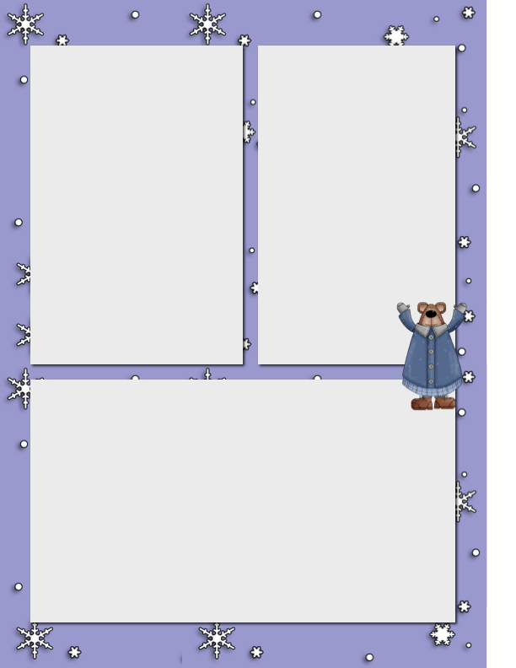

**Y.E.S.**

The time is almost here to have all our information online for March. 1st, 2021. By next week parents and children should send the following to me or Mr. Hayes. A little write up of children’s business, pictures of materials to be sold online, prices or price list, and a logo which will be important. The logo can be a picture of their logo and sent to me. To make sure everyone’s store is open for March. 1st It’s imperative to have all that information next week. Lots of children and parents have been busy and have seen so many wonderful pictures of dedicated children working hard! I love this project and although it’s different this year I think it will still be valuable and exciting experience. I appreciate all the help that parents have lent me and the children their hard work will hopefully not go unnoticed. I am in talks with Big White right now about how to spread the word of this starting next week and I hope that with the efforts we will help all children be successful.

**Outdoor Building Wednesdays**

Our outdoor building days have been getting better each year! We are hoping to really make a effort to have kids outside all year round. This has been a good experience for the kids and we are finding that most are engaged and are very happy outside building or helping with others!

**Mr. Hayes Class**

The last two weeks have seemed to go by very quickly in the intermediate class.  The students have been spending the majority of their time learning about poetry and human systems.

The students have been creating their own original poems using various forms.  So far we have explored Haiku, Tanka, Extended Metaphor, Free Verse, and a poetry style of their choosing.  The students have been building their unit on their blog and all of the new works are being based on a topic of their choosing.  Believe it or not a lot of the class has been doing a theme that is snow related.  They are just beginning to dive into how to analyse poems and interpret their meaning and what poetic devices are being used.

In our Human Systems unit, the students are exploring the information through PowerPoint presentations, group discussions, illustrations, use of an anatomical model, and drawing their own models of each system.   So far, we have explored the digestive system and the nervous system.

This week the students learned about how to build snow caves.  After a brief lesson we had the chance to build our own outside.  At the end of our build the students came up with a good question about why talking to someone through the air vent sounded differently.  We dove into that Thursday morning and what we found out about sound waves and snow was very interesting.